-- To view the data in the tables (all columns)

select * from order_details;

select * from pizzas

select * from orders

select * from pizza_types;

**-- To answer the business question, what is the total number of orders placed?**

select count(distinct order_id) as 'Total Orders' from orders;

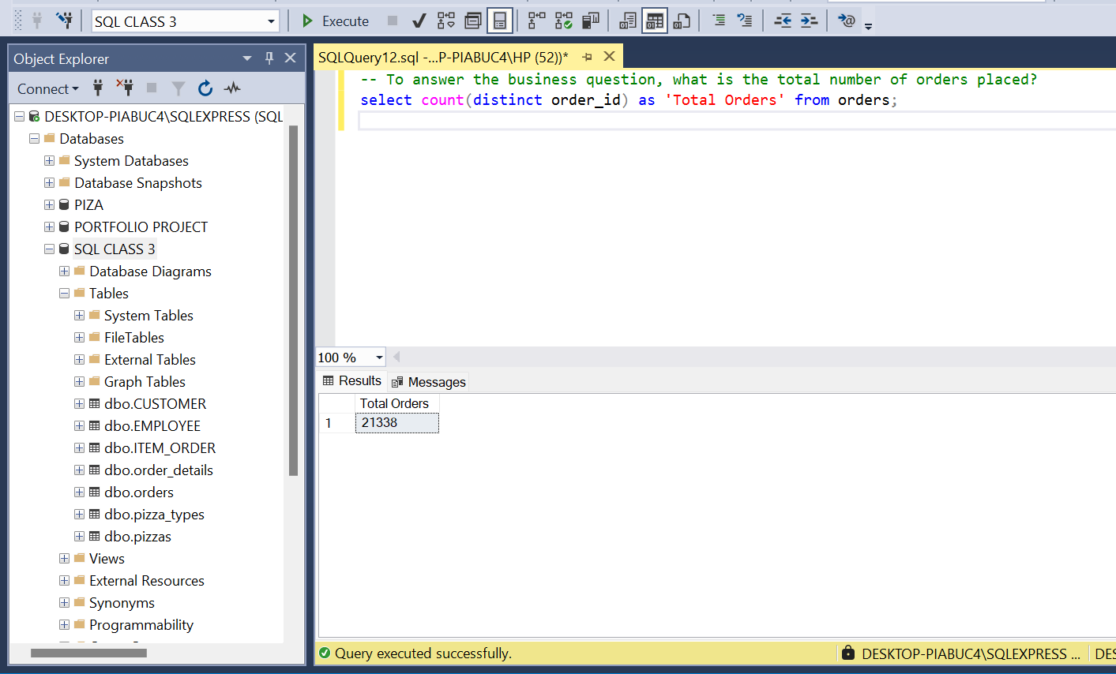

**-- To calculate the total revenue generated from pizza sales.**

**-- First let’s join the order_details and pizzas table to see the details**

select order_details.pizza_id, order_details.quantity, pizzas.price

from order_details

join pizzas on pizzas.pizza_id = order_details.pizza_id

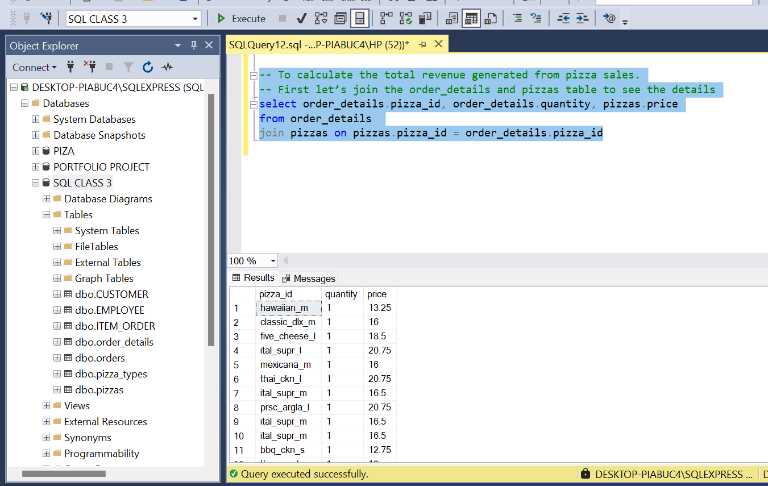

**-- to get the total revenue**

select cast(sum(order_details.quantity * pizzas.price) as decimal(10,2)) as 'Total Revenue'

from order_details

join pizzas on pizzas.pizza_id = order_details.pizza_id

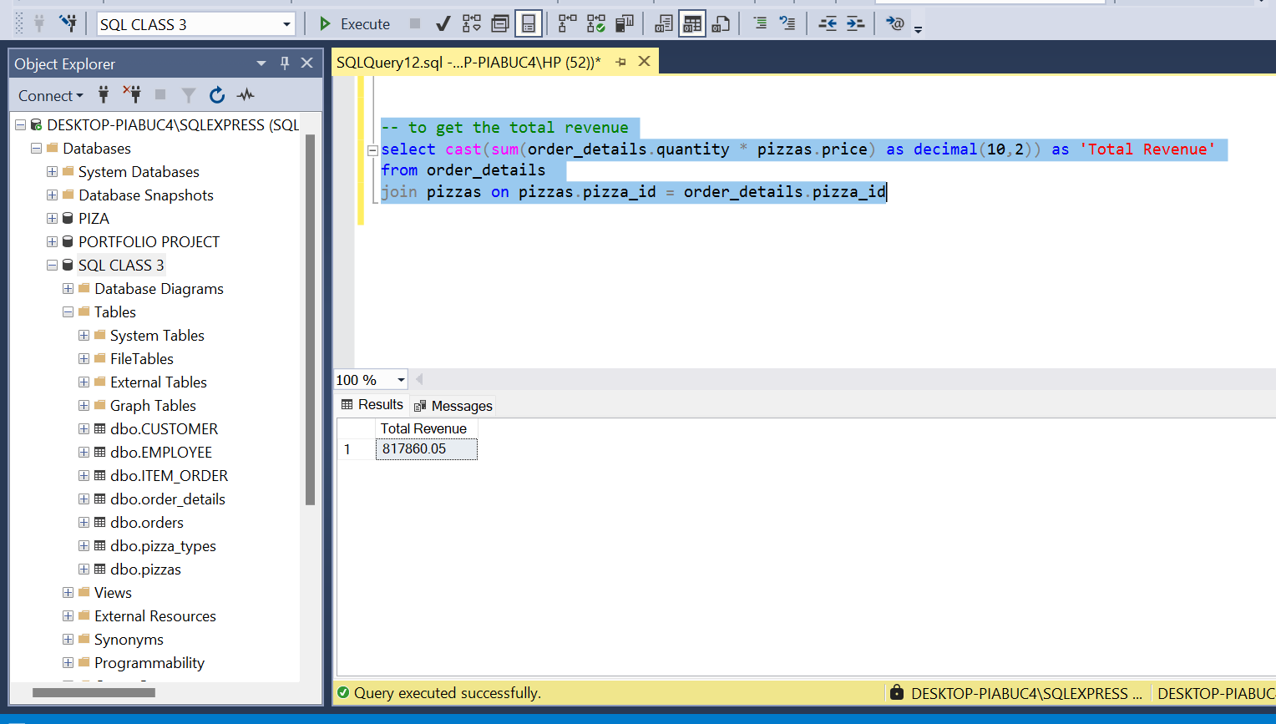

**-- To answer the business question, What is the common pizza size ordered?**

SELECT

pizzas.size,

COUNT(DISTINCT order_id) AS 'No of Orders',

SUM(quantity) AS 'Total Quantity Ordered'

FROM

order_details

JOIN

pizzas ON pizzas.pizza_id = order_details.pizza_id

GROUP BY

pizzas.size

ORDER BY

COUNT(DISTINCT order_id) DESC;

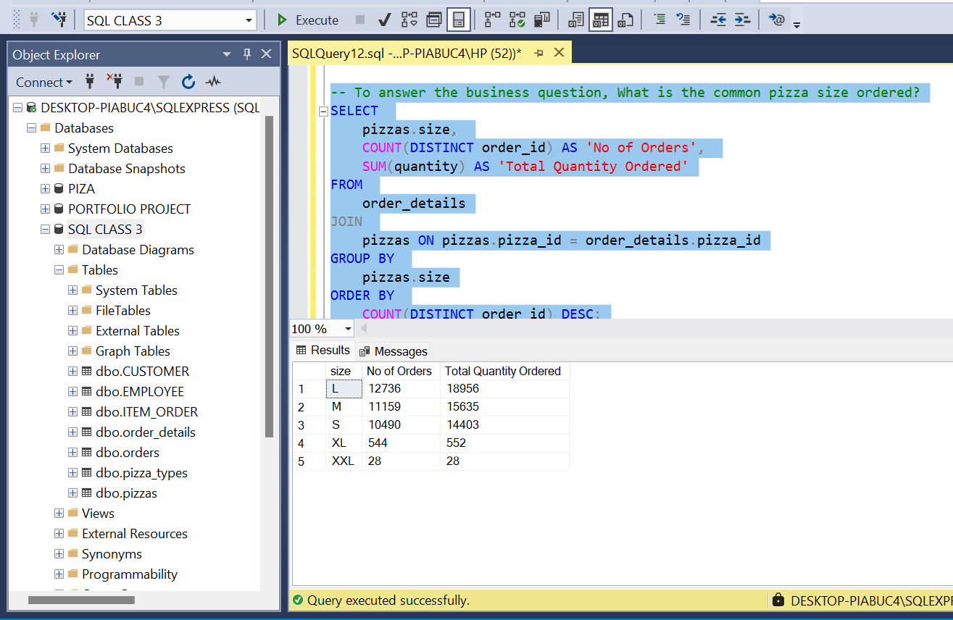

**-- To calculate the** **top 3 most ordered pizza types based on revenue**

SELECT TOP 3

pizza_types.name,

SUM(order_details.quantity * pizzas.price) AS 'Revenue from pizza'

FROM

order_details

JOIN

pizzas ON pizzas.pizza_id = order_details.pizza_id

JOIN

pizza_types ON pizza_types.pizza_type_id = pizzas.pizza_type_id

GROUP BY

pizza_types.name

ORDER BY

[Revenue from pizza] DESC;

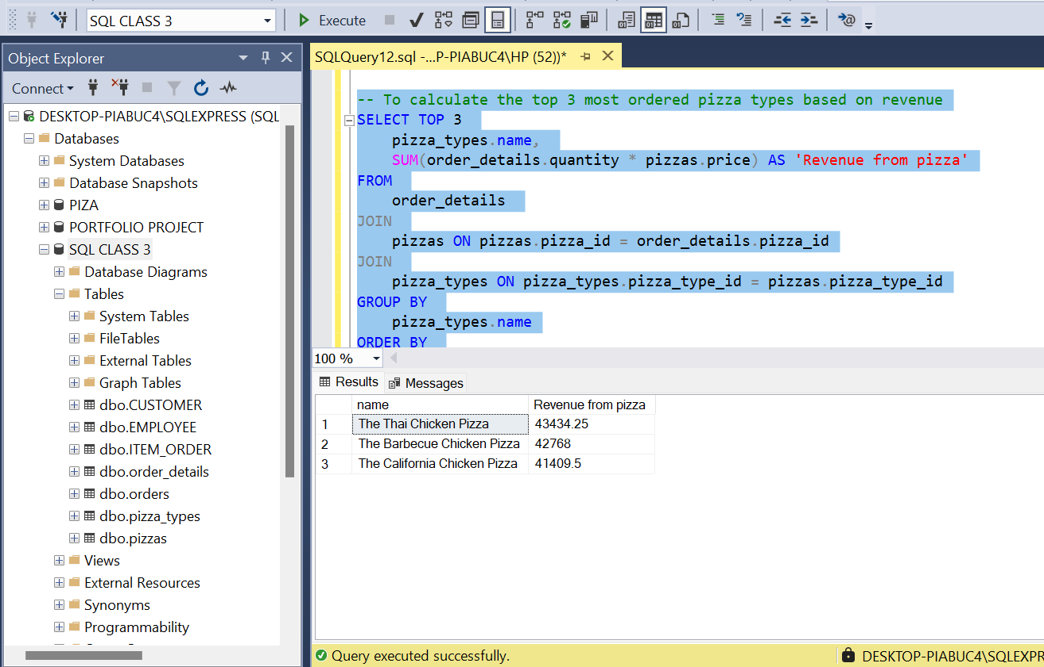

**--INVENTORY MANAGEMENT**

**-- Determine the distribution of orders by hour of the day.**

SELECT

DATEPART(hour, time) AS 'Hour of the day',

COUNT(DISTINCT order_id) AS 'No of Orders'

FROM

orders

GROUP BY

DATEPART(hour, time)

ORDER BY

[No of Orders] DESC;

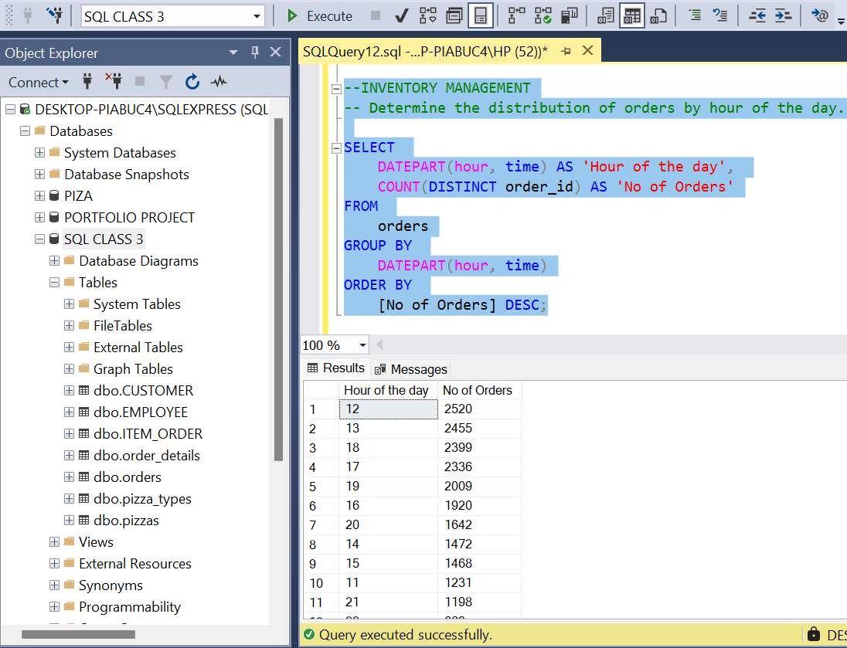

**-- To answer the business question- Which ingredients are most frequently used and should be stocked more regularly?**

-- Step 1: Create a CTE to split the ingredients

WITH IngredientCTE AS (

SELECT

pt.pizza_type_id,

pt.name,

LTRIM(RTRIM(value)) AS ingredient

FROM

pizza_types pt

CROSS APPLY STRING_SPLIT(pt.ingredients, ',')

)

-- Step 2: Join the split ingredients with order details and calculate usage

SELECT

ic.ingredient,

SUM(od.quantity) AS ingredient_usage

FROM

IngredientCTE ic

JOIN

pizzas p ON ic.pizza_type_id = p.pizza_type_id

JOIN

order_details od ON p.pizza_id = od.pizza_id

GROUP BY

ic.ingredient

ORDER BY

ingredient_usage DESC;

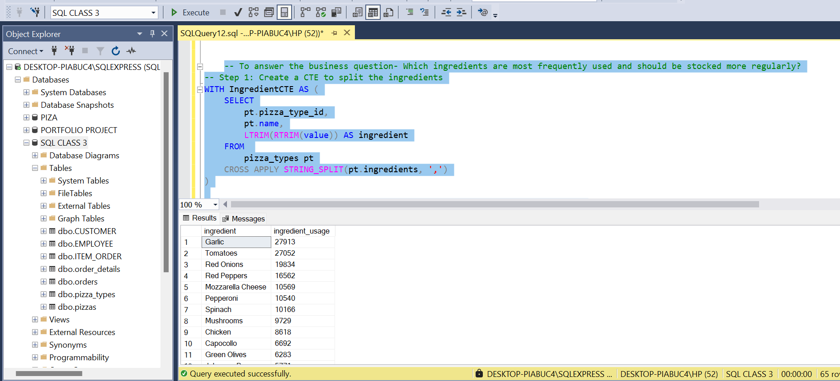

**-- To answer the business question-Can we identify any seasonal trends in pizza demand?**

--First, we will aggregate the data by month to see the total number of pizzas ordered each month.

SELECT

DATEPART(YEAR, date) AS Year,

DATEPART(MONTH, date) AS Month,

SUM(order_details.quantity) AS TotalPizzasOrdered

FROM

orders

JOIN

order_details ON orders.order_id = order_details.order_id

GROUP BY

DATEPART(YEAR, date),

DATEPART(MONTH, date)

ORDER BY

Year, Month;

**--Let’s check if we can identify any trends per quarter**

SELECT

DATEPART(YEAR, date) AS Year,

DATEPART(QUARTER, date) AS Quarter,

SUM(order_details.quantity) AS TotalPizzasOrdered

FROM

orders

JOIN

order_details ON orders.order_id = order_details.order_id

GROUP BY

DATEPART(YEAR, date),

DATEPART(QUARTER, date)

ORDER BY

Year, Quarter;

**--Let’s check if we can identify any trends per season (winter, summer, fall, spring)**

SELECT

DATEPART(YEAR, date) AS Year,

CASE

WHEN DATEPART(MONTH, date) IN (12, 1, 2) THEN 'Winter'

WHEN DATEPART(MONTH, date) IN (3, 4, 5) THEN 'Spring'

WHEN DATEPART(MONTH, date) IN (6, 7, 8) THEN 'Summer'

WHEN DATEPART(MONTH, date) IN (9, 10, 11) THEN 'Fall'

END AS Season,

SUM(order_details.quantity) AS TotalPizzasOrdered

FROM

orders

JOIN

order_details ON orders.order_id = order_details.order_id

GROUP BY

DATEPART(YEAR, date),

CASE

WHEN DATEPART(MONTH, date) IN (12, 1, 2) THEN 'Winter'

WHEN DATEPART(MONTH, date) IN (3, 4, 5) THEN 'Spring'

WHEN DATEPART(MONTH, date) IN (6, 7, 8) THEN 'Summer'

WHEN DATEPART(MONTH, date) IN (9, 10, 11) THEN 'Fall'

END

ORDER BY

Year, Season;

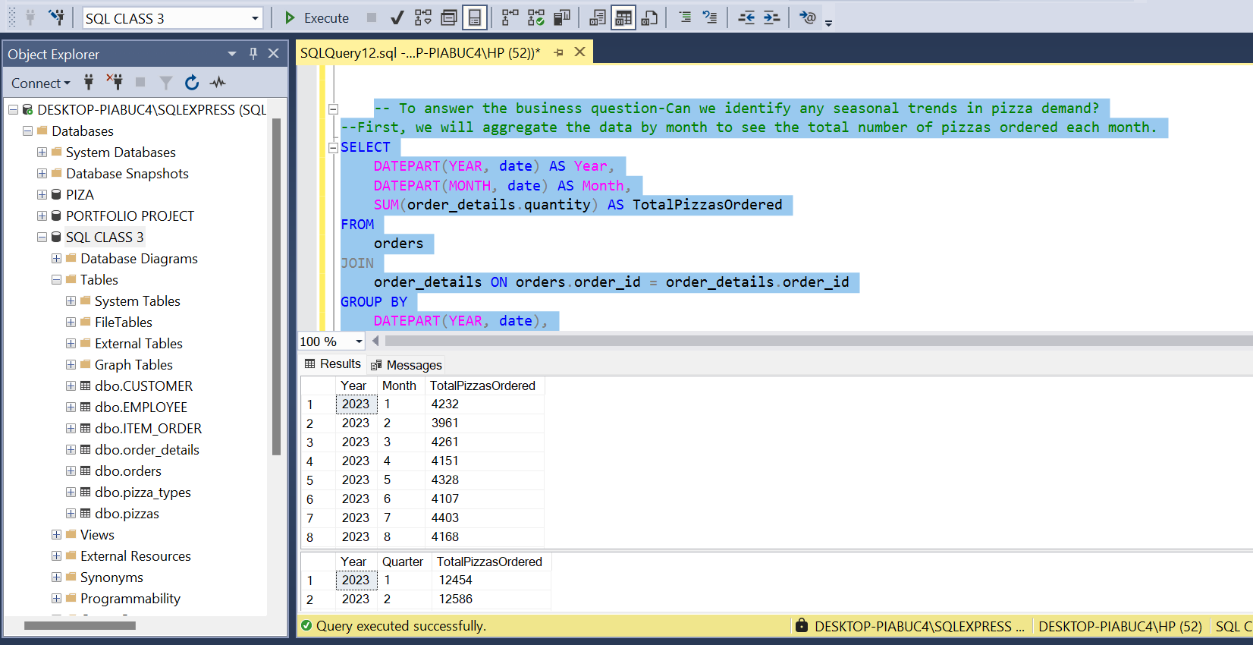

**--Customer Preferences**

**--To answer the business question what are the top 5 most ordered pizza types along with their quantities.**

select top 5 pizza_types.name as 'Pizza', sum(quantity) as 'Total Ordered'

from order_details

join pizzas on pizzas.pizza_id = order_details.pizza_id

join pizza_types on pizza_types.pizza_type_id = pizzas.pizza_type_id

group by pizza_types.name

order by sum(quantity) desc

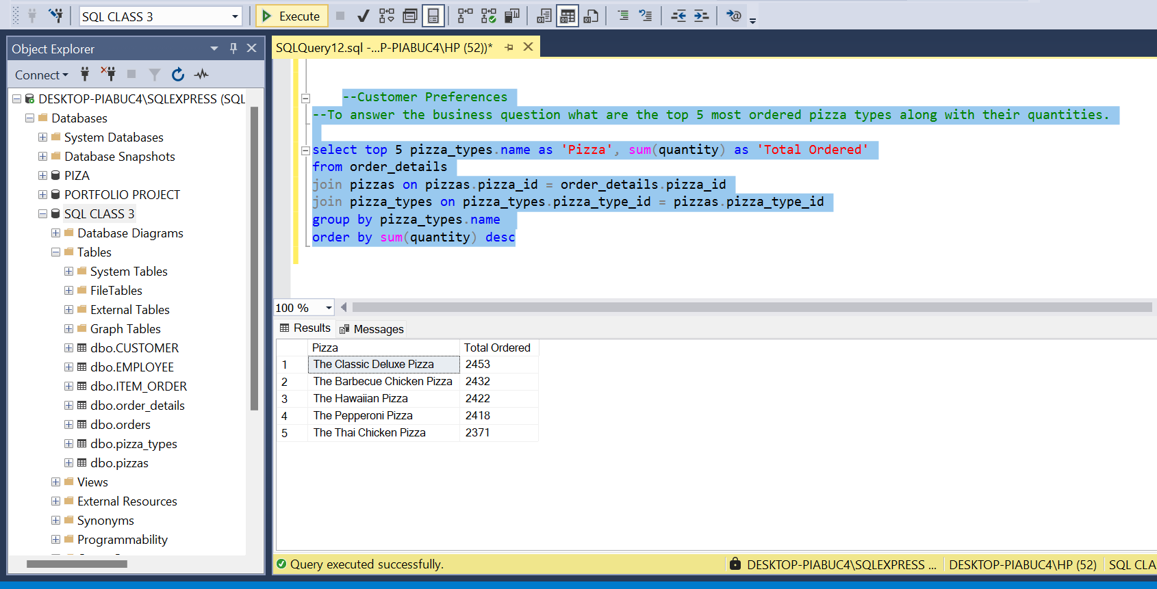

**--To answer the business question what is the total quantity of each pizza category ordered**

-- Join the necessary tables to find the total quantity of each pizza category ordered.

select top 5 pizza_types.category, sum(quantity) as 'Total Quantity Ordered'

from order_details

join pizzas on pizzas.pizza_id = order_details.pizza_id

join pizza_types on pizza_types.pizza_type_id = pizzas.pizza_type_id

group by pizza_types.category

order by sum(quantity) desc

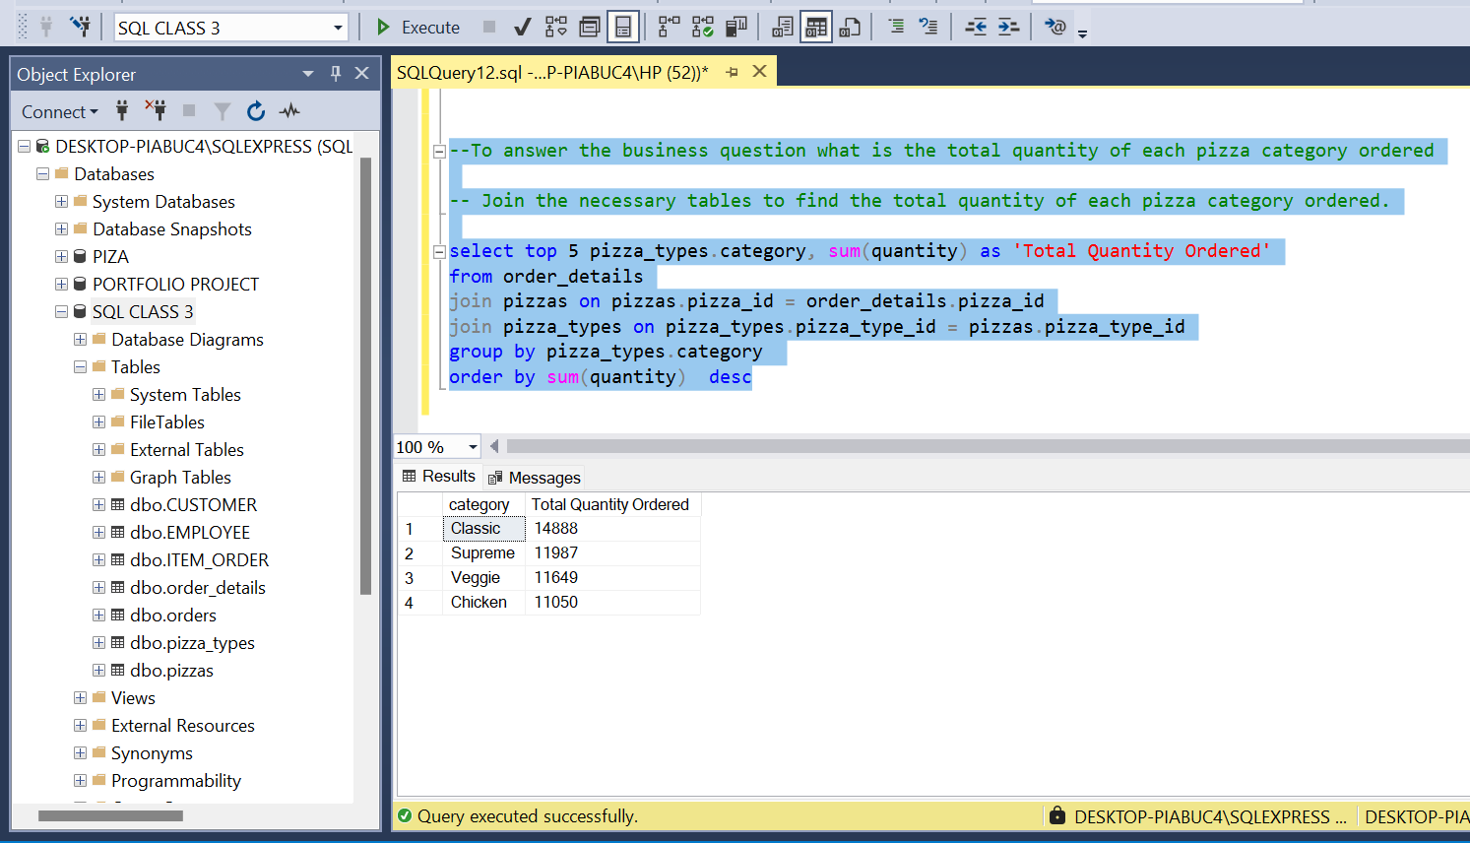

**--To answer the business question what is the category-wise distribution of pizzas?**

select category, count(distinct pizza_type_id) as [No of pizzas]

from pizza_types

group by category

order by [No of pizzas]

**--To answer the business question what is the category-wise distribution of pizzas?**

select category, count(distinct pizza_type_id) as [No of pizzas]

from pizza_types

group by category

order by [No of pizzas]

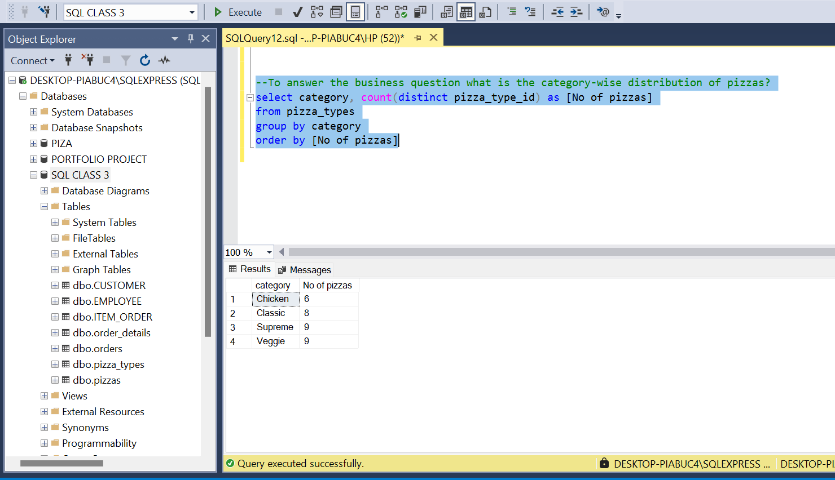

**--To answer the business question what are the peak hours and days for orders?**

SELECT

DATENAME(WEEKDAY, date) AS DayOfWeek,

DATEPART(HOUR, time) AS Hour,

COUNT(order_id) AS NumberOfOrders

FROM

orders

GROUP BY

DATENAME(WEEKDAY, date),

DATEPART(WEEKDAY, date),

DATEPART(HOUR, time)

ORDER BY

NumberOfOrders DESC;

